National University of Computer and Emerging Sciences, Lahore Campus

 | Course: | Database Systems | Course Code:
 | Program: | BS(DS) | Semester: | Spring 2023
 | Date: | 14-Feb-2023 | Total Marks: | 10
 | Section: | C | Weight:
 | Quiz: | 1 | Page(s): | 2
Instructions Clearly mention any assumption you have made.

Q1. (2 marks)

Person Employee
Eno | Name | DOB | City
1 | Ali | 12-1-21 | Lahore
2 | Haris | 30-2-21 | Karachi
3 | Rida | 4-2-21 | Islamabad
4 | Hira | 5-2-21 | Faisalabad
5 | Aiman | 6-2-21 | Murree
Eno | Name | Designation
1 | Ali | Manager
2 | Haris | Ceo
3 | Aiman | Cto

Relation 1 Relation 2

- If Eno is a key in both relations, which relation is referencing and which is the reference relation? (1 mark)

- Write down the names of the schema base constraints and identify all possible keys, candidate keys and super keys from the table above. In case of no valid option, state your reason why. (5 marks)

Q2. (3 marks)

Name | Eno | City
Rida | 2 | Lahore
Aiman | 1 | Karachi
Hira | 3 | Peshawar
Rida | 2 | Lahore
Asad | 5 | Murree

- Identify which constraint(s) are being violated in this RDMS table. State reasons for your answer.

Q3. (2 marks)

Table 1 Table 2

Eno | Name | Height
1 | Rida | 5’ 4’’
2 | Fatima | 5’ 6’’
3 | Hira | 5’ 2’’
Eno | City
1 | Lahore
3 | Karachi

Perform the following operations. In case of an invalid operation, provide valid being for it being incorrect. (2 marks)

- Insert row (4,Peshawar) in table 2.

- Update (1,Lahore) to (5,lahore) in table 2.

- Delete (1, Rida , 5’ 4’’) from table 1.

- Insert (2 , Peshawar) in table 1.

Q4. Consider the following patient database:
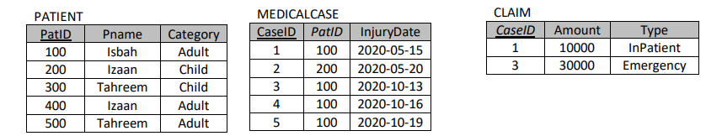
NOTE: In the above schema PKs are underline and patID in medicalcase table and caseID in claim table are Foreign Keys.
- (3 points) Give the Output of the following query for the Database State given above.

SELECT P.patID, P.Pname, P.category FROM patient AS P LEFT OUTER JOIN medicalcase AS M ON P.patID=M.patID WHERE P.category != ‘Child’ AND M.caseID IS NULL

